## BAHRIA UNIVERSITY

## Karachi Campus

## http://www.university-directory.eu/instlogos/PK-Bahria-University--Karachi-Campus.jpg

**Remarks**

**PROJECT TITLE:** DENTAL CLINIC MANEGEMENT SYSTEM

**Project Details**

|  |  |  |  |  |  |
| --- | --- | --- | --- | --- | --- |
| Project Title | | Dental Clinic Management System | | | |
| Course Code | | ---- | | | |
| Course Name | | Data Structures And Algorithm | | | |
| Instructor Name | | Sir Irfan Mustafa | | | |
| Department | | INFORMATION TECHNOLOGY | | | |
| Due Date | 25-may-2018 | Submission Date | 25-may-2018 | Code | ---- |

**MUHAMMAD SHAHZEB CHAUDHRY 45920**

**RIZWAN ALI 45922**

**SAAD ZAFAR 45923**

**SUMAIR ALI 45925**



|  |  |  |
| --- | --- | --- |
| **S.NO** | **TOPICS** | **P.NO** |
| **1** | **ABSTRACT** | 3 |
| **2** | **KEYWORDS** | 3 |
| **3** | **INTRODUCTION** | 4 |
| **4** | **BACKGROUND** | 4 |
| **5** | **GENERAL DESCRIPTION** | 5 |
| **6** | **PROBLEM STATEMENT** | 5 |
| **7** | **SYSTEM OBJECTIVES** | 5 |
| **8** | **OPERATION ENVOIRMENT** | 5 |
| **9** | **EXPERIMENTS** | 6-7 |
| **10** | **CONCLUSION** | 8 |
| **11** | **REFRENCES** | 9 |

**INDEX:**

**ABSTRACT**

Abstract: Most of medical sectors today are using network services and offering Online web services in order to create more benefits for both their stakeholders and themselves, including the way of how people make booking. As a result, one system called Dental Clinic Management System with Notification using web will be develop to resolve all the current problems at clinic. The objective of this project is develop Decision Support System for Dental Clinic that provide information about the dentist profile, patient information include patient personal detail, patient treatment, patient appointment, patient billing, and dental treatment and disease. During the system development “DEV C++” is used in order to create interface and coding. This system is gives advantages to the all both users clinic staff and end user especially patient, where the two users can access the system

**Keywords:**

**Case:** a block of code in a switch statement

**Char:** declare a character variable

**Double:**  declare a double precision floating-point variable

**Void:** declare functions or data with no associated data type

**Default:**  default handler in a case statement

**Double:** declare a double precision floating-point variable

**Else:**  alternate case for an if statement

**For:**  looping construct

**If:** execute code based off of the result of a test

**Int:**  declare a integer variable

**Long:**  declare a long integer variable

**Namespace:**  partition the global namespace by defining a scope

**New:**  allocate dynamic memory for a new variable

**Switch:** execute code based off of different possible values for a variable

**Introduction:**

Dental Clinic is an organization that is responsible in providing a health medication and treatment for all types of dental patients. Surely, everyday there are people that need to use the dental clinic services. But how can clinic provide a faster and efficient services if they are still using the traditional method on their daily operation. The traditional method means the customers need to fill in their detail in registration form manually and the information will only keep in files. After the registration, the files will be place in the rack and this will cause problems like taking a longer time to retrieve the information, make mistakes during writing or misplaced the files. Nowadays, technology has changed many aspects of life and people’s daily life is becoming indivisible from the network due to the development of Internet. With dental clinic management system, the process gets much faster and more efficient than traditional way. Even though the dental clinic had a system, but they still do not use the application. It is because there are facing several problems during process management. So, people from outside cannot view their treatment examination that they have done in the dental clinic. There are also problem when the patient forgot their appointment time because they cannot check their appointment schedule through online. Although the appointment schedule was provided in the manual, it is possible that the paper will be missing. Dental Clinic Management System with Notification is specially designed to let the clinic staff has a high efficiency management tools, computerized and systematic patient’s record, and detail of treatment records

**Background:**

Dental clinic management System is a Program which is using to record the information of patients and doctors. In this program we can store the detailed information of the patients, doctors and receptionist. It is a very useful program for clinic information department.

System eliminates the paper work, record every transaction in computerized system so that problem such as record file missing won’t be happen it saves the cost and time.

All modules will be able to help staff to manage with more convenience and in a more efficient way as compared to other systems which are not computerized.

**General Description:**

This system provides quick processing service to public and up to date statistics to authorities. The Clinic Management System has the following features:

**Easy Processing**: The system takes a hassle-free approach towards applying for appointment.

**Authenticity**: It gives the authentication to receptionist for confirmation of appointment.

**Reporting**: System provides extensive reporting options to management.

**Scalability:** System is scalable to integrate with other systems and networks of the Clinic as per the need.

**Problem Statement:**

Normally the patients who are the students and the staff present identification cards at the reception which are checked to verify whether they have their records or files there. If not ,a new file is created containing the staff identification details and in which future consultation details will be recorded. If the file is already there, the patient is asked to go to the consultation room where he or she is diagnosed and the details recorded in the patient’s file. The patient is either referred to the laboratory or treatment room for tests and medication respectively depending on the situation.

**System Objective:**

It is the user friendly system for Hospital which reduces the burden and helps to manage all sections of Clinic like reception, lab, inpatient/outpatient management and Billing etc., which improve the processing efficiency.

**Operation environment:**

**Operating system**: windows 7/ XP/10

**Front end**: C++

**Language**: C++

**Experiments:**

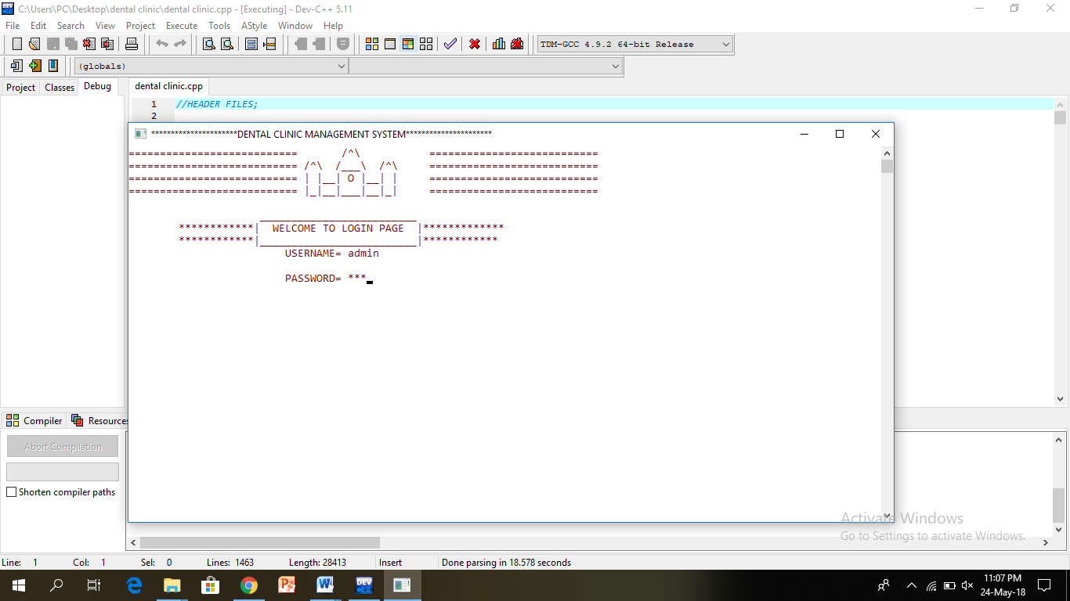

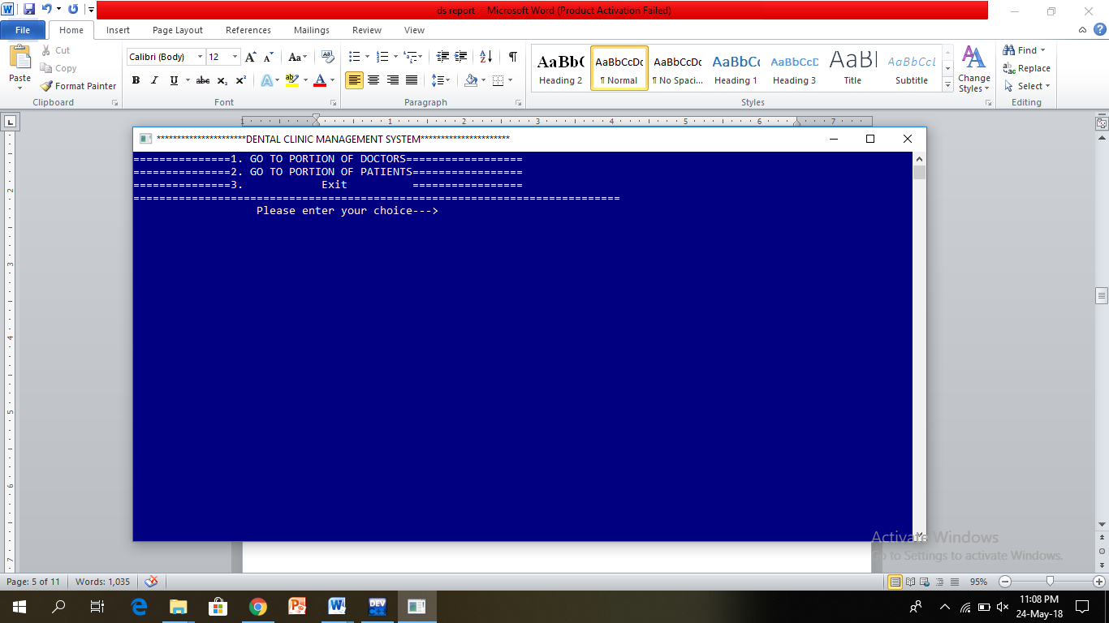

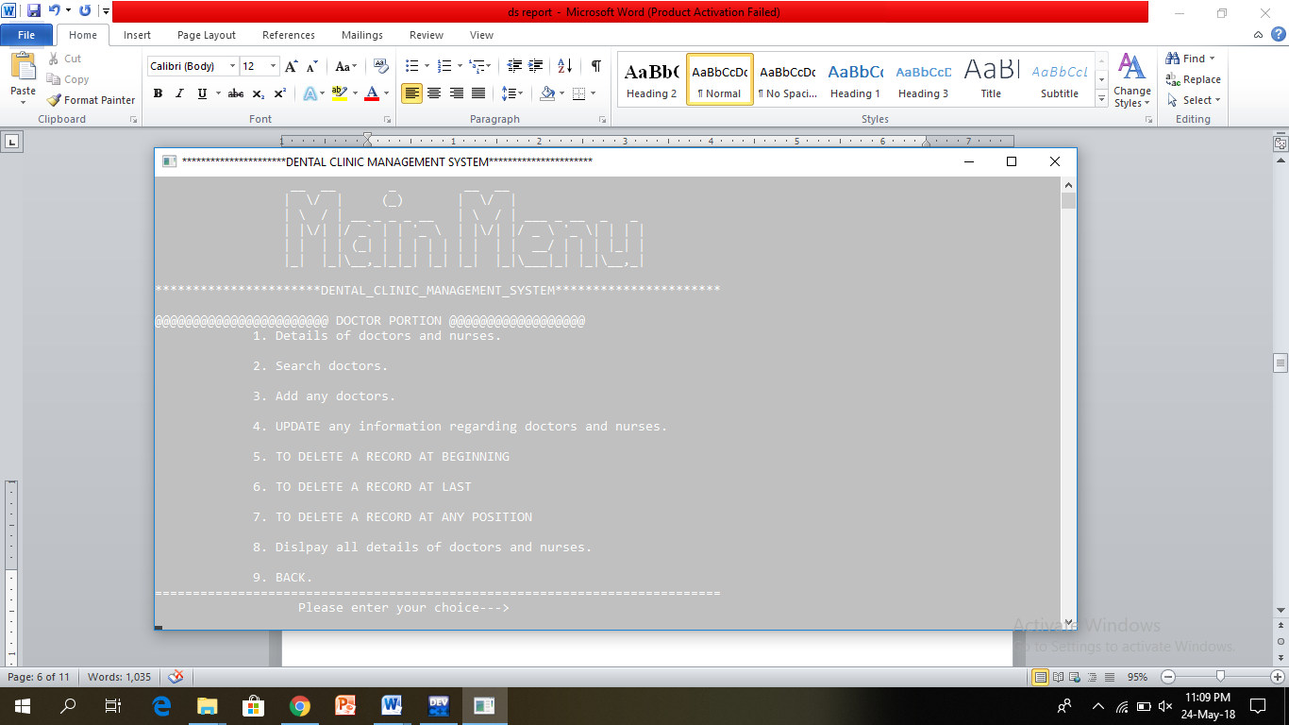

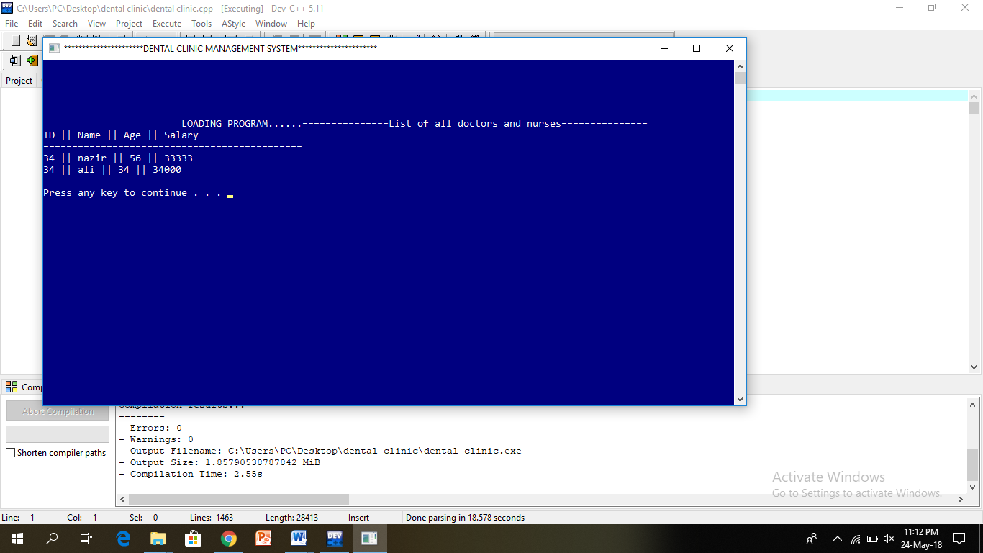

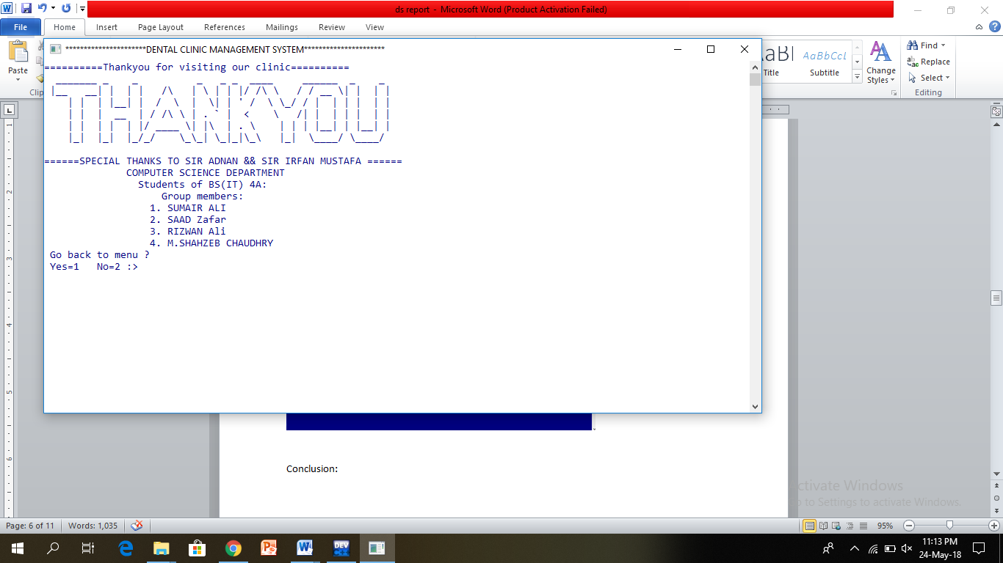

**Conclusion:**

This project will enhance the dental clinic management system to serve more quickly and efficiently. This software will be developed in order to computerize the activities which take more time, if done manually. Dental clinic management system will enable the patients and doctors to make things faster and can get information quickly. If we want any information about patients and doctor, we can access it quickly.

**References:**

[1] Peter McMahon, [Book], “An Introduction to ASP.NET”, retrieved on May 20, 2012, from [www.dotnet.za.net/book/IntroToASP.NET.pdf](http://www.dotnet.za.net/book/IntroToASP.NET.pdf)

[2] “Web Application Architecture, principles, protocols and practices” by Leon Shklar, Richar Rosen, [Book], Retrieved on May, 2012.

[3] Tai BC, Seldrup J (2000), “A review of software for data management, design and analysis of clinical trials”. Ann Acad Med Singapore 29(5):576

[4] http://ijcset.net/docs/Volumes/volume6issue5/ijcset2016060507.pdf